Greg Best
Consulting, Inc.
16100 Outlook Avenue
Stilwell, KS 60085
816-792-2913

May 9, 18

DESCRIPTION OF DTS FACILITY

INTRODUCTION
WLGA is licensed to CNZ Communications SE, LLC (“CNZ”) as a Full-Service television station, currently on Channel 30 in Opelika, AL. In the Post-Incentive-Auction spectrum repack, it has been assigned to Channel 17. It is one of the 50 stations that were found by the FCC to be predicted to receive more than one percent new interference on their newly-assigned channels. The bulk of that new interference will be from adjacent-channel Station WUVG, which will be moving to Channel 18 in Atlanta, GA.

The adjacent-channel interference from WUVG to WLGA is predicted to occur in the northeast region of the WLGA service area, where there is terrain blockage of the WLGA signal by an intervening ridge line. Because of the ridge line, increasing power at the current WLGA transmitter site would not be sufficient to overcome the signal level losses and the resulting interference from WUVG. Consequently, to recoup service to the population lost in the repack, CNZ has elected to install a distributed transmission system (“DTS”) network, placing an additional transmitter near the top of the ridge line to provide service to the northeastern sector of its service area.

CNZ initially submitted a DTS network design that proposed moving its existing transmitter site to the northeast to help increase signal levels there. There was a resultant loss in predicted service in the southern reaches of the authorized WLGA service area, which FCC Video Division staff found objectionable. The revised DTS network design described herein does not propose to move the existing transmitter site and has no such loss. Rather, it is focused on extending the WLGA service to the northeast through a change in the station’s reference point and addition of the transmitter needed to recover service in the area lost to adjacent-channel interference.

The revised DTS proposed herein complies with the FCC rules for DTS facilities. The DTS consists of two transmitter sites, with a new reference point located north of WLGA’s existing location. The resulting DTS service area covers the equivalent area served by the “largest station in the market.” Shifting the reference point, meanwhile, allows WLGA to provide service to the area affected by the WUVG-CP without creating any new loss area.

DTS SYSTEM CHRONOLOGY AND TECHNICAL DESCRIPTION

REFERENCE POINT AND LIMITING CIRCLE

The FCC rules related to DTS authorizations and the Report and Order that established them provide for relocation of the Reference Point of a station and also define the size of the circle (“Reference Circle” hereinafter) that can be used to limit the placement of transmitters and the extent of their contours. The radius of the Reference Circle can be either that given in the Table of Distances in Section 73.626(c) or that of a circle having an area matching the service are of the “largest station within their market” per §73.622(f)(5). The market is the DMA of the station. In the case of WLGA, the DMA is Columbus, GA, and the largest station in the market is WTVM, with a service area of 45,114 sq km. The radius of a circle having an area matching the service area of WTVM is 119.8 km.

On the map at the end of this Description, the Reference Circle is denoted by a dashed red line. The Reference Point is positioned so that the Reference Circle fully encompasses the current Authorized Service Area of WLGA, represented by the dashed green contour. This meets the geographical requirements related to relocation of the Reference Point as provided in the DTS Report and Order at ¶ 29. The Reference Circle’s radius of 119.5 km is within the 119.8 km radius circle of WTVN, consistent with 73.622(f)(5). As discussed below, the proposed facility includes a minimal extension outside of the Reference Circle to overcome adjacent-channel interference within the Reference Circle.

NEW DTS SITE LOCATION AND COVERAGE

The DTS sites chosen attempt to provide service to the entire reference circle. Providing service to the northern portion of the reference circle is challenging because of the WUVG-CP signal strength.

DTS COVERAGE AND INTERFERENCE COMPLIANT WITH FCC 73.626

Coverage is provided by two sites that overlap and cover the entire authorized service area of the repacked WLGA channel, satisfying Sections 73.626 (f)(1), (f)(3), and (f)(6), as shown in the map below. Principal city of license coverage is provided by Site #1, satisfying Section 73.626(f)(4), and also illustrated on the map below.

An interference study using TV Study was executed to determine if any interference above the acceptable threshold of 0.5% was caused or received. The results of the study are attached to the application and they indicate the proposed DTS causes no objectionable interference (i.e. greater than 0.5% to any full service or Class A station) as required in Section 73.626 (f)(5). Both site’s coverage contours are contained within the Reference Circle except for a small excursion outside the reference circle from Site #2 which is believed to be considered as de minimis in keeping with Section 73.626(f)(2). The minimal contour extension beyond the Reference Circle is necessary to overcome the strong signal strength of WUVG-CP. If the minimal contour extension did not exist, WLGA would receive 4.1 % interference from WUVG-CP. Even with this de minimis contour extension beyond the Reference Circle, the population inside the proposed WLGA protected contour receives 2.19 % interference. While this is not desirable, it is an acceptable tradeoff.

DESCRIPTION OF SITES

Site #1
The southern region within the Reference Circle will be covered by the transmission facility at the existing WLGA transmitter location. A new side-mounted slot antenna (TFU-20-DSC /VP-R C180) antenna pattern has been chosen to permit coverage to the extent of the Reference Circle to the south while keeping the power to the north reduced so that self-interference is reduced. Although some further customization of the pattern may be desirable to the north to limit the self-interference, that customization will not create a loss area.

Site #2
The population in the northern portion of the Reference Circle receives its signal from Site #2 which is located at ASR 1018795. This site has clear line of sight to the area experiencing interference from WUVG-CP whereas the WLGA Site #1 does not. There is “reasonable assurance” of the ability to locate at this additional site. Contact was made with the engineering consultant for the tower facilities and space is available at the height chosen (820 ft RCAGL) for the proposed transmission system.

The antenna pattern that works for this site is a tradeoff of many parameters. Specifically, the signal to the north must be as high as possible to provide reception up to the Reference Circle. The signal to the south must be as low as possible in order to avoid self-interference with the signal from Site #1. The signal provided to the east and west must be high enough to encompass the authorized service area for the initial repack assignment for WLGA but not interfere with WDMA to the east.

To accomplish those objectives, a panel antenna pattern with model TUM30-C2-8/16H-1 has been chosen but may need some customization to reduce the self-interference potential in the overlap region of the two site contours.

See the map below to view the proposed DTS transmission sites, the associated contours, Reference Circle and coordinates, the WUVG-CP contour, and the remaining received interference from WUVG.

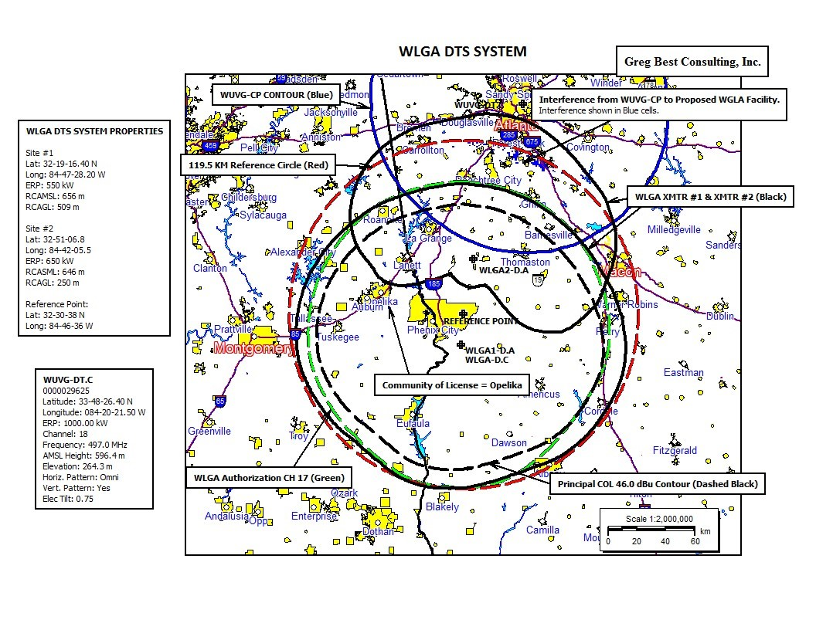

Sincerely,

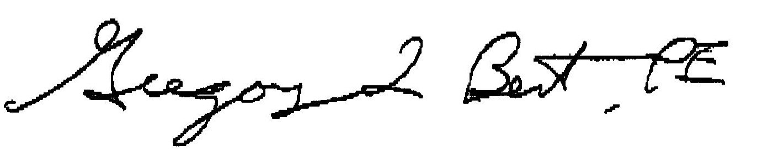
Consulting Engineer

See Incentive Auction Closing & Channel Reassignment Pub. Notice the Broad. Television Incentive Auction Closes; Reverse Auction & Forward Auction Results Announced; Final Television Band Channel Assignments Announced; Post-Auction Deadlines Announced, Public Notice, 32 FCC Rcd. 2786 (2017); http://data.fcc.gov/download/incentive-auctions/Transition_Files/Pop_Loss_Indicator.csv.
FCC File BLANK0000029625, (“WUVG-CP”)
See Expanding the Economic and Innovation Opportunities of Spectrum Through Incentive Auction, Report & Order, 29 FCC Rcd. 6567 ¶ 175 (2014) (stating that a licensee may use DTS to “provide service to a specific area that had service on its pre-auction channel but lacks service on its new channel.”
47 C.F.R. § 73.626.
Id. § 73.622(f)(5).
See In the Matter of Digital Television Distributed Transmission System Technologies, Report and Order, MB Docket No. 05-312, FCC 08-256 ¶ 35 (Nov. 3, 2008) (hereinafter the “DTS Report and Order”).
FCC File BLCDT-20131113BGN.
Id. ¶ 29.
FCC File Blank0000034487.

