2305 Vida Shaw Rd, New Iberia, LA 70563

Phone: 303-378-8209
E-Mail: stcl@comcast.net
B. W. St. Clair

KHHI-LD
FI 52919

The Applicant has been operating under Special Temporary Authority at this location. No new construction involved. Parameters of this modification are identical to the STA

Sincerely,
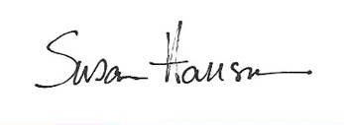

Susan Hansen
President / Consultant
March 16, 2021

