THE FOLLOWING STATIONS ARE INCLUDED IN THIS APPLICATION:

K207EI EMPORIA, KS FAC# 78541 KAWZ

K203EU HUTCHINSON, KS FAC# 77282 KAWZ

THESE STATIONS ARE EXCLUDED BECAUSE THEIR ERP IS LESS THAN 100 WATTS, AS NOTED IN SECTION 1.1307(b)(1) OF THE COMMISSION’S RULES.

ALL APPROPIATE STEPS TO INSURE THAT WORKERS, WHO CLIMB THIS TOWER WILL NOT BE EXPOSED TO LEVELS OF NON IONIZING RADIATION, WILL BE TAKEN. THESE STEPS INCLUDED A REDUCTION IN POWER OR CESSATION OF OPERATION, AS APPROPRIATE, WHEN WORK BECOMES NECESSARY ON THE TOWER IN THE AREA WHERE THE POWER DENSITY LEVELS ARE IN EXCESS OF THE PERMITTED LEVEL FOR CONTROLLED EXPOSURE.

K208EK PARSONS, KS FAC# 92264 RF STATEMENT

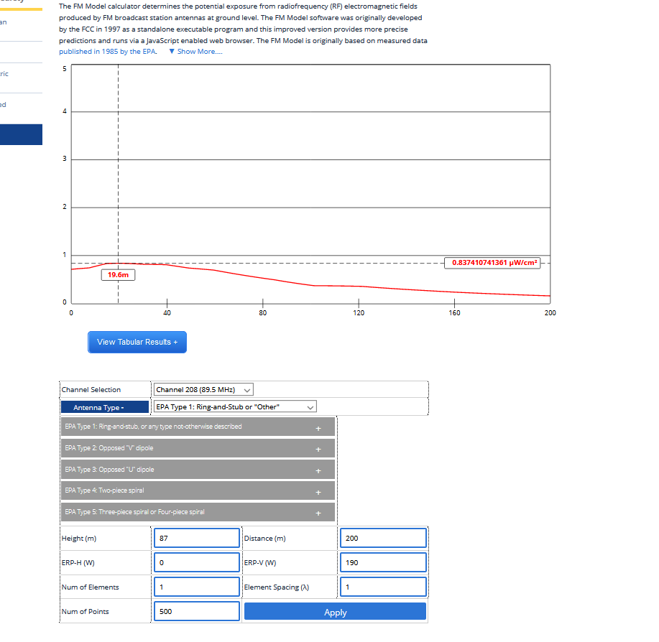

K204DQ WICHITA, KS FAC# 93158 RF STATEMENT

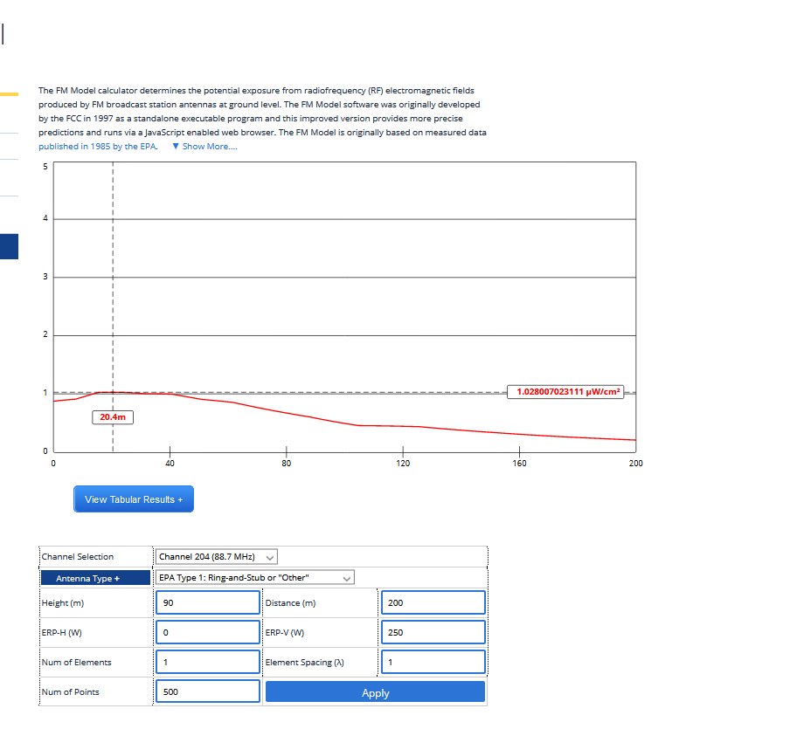

K208FE TOPEKA, KS FAC# 79216 RF STATEMENT

