Greg Best
Consulting, Inc.
16100 Outlook Avenue
Stilwell, KS 66085
816-792-2913

August 20, 2018
Federal Communications Commission
Media Bureau
445 12th Street SW
Washington, DC 20554
Dear Sir,
This exhibit explains the status of the tower structure overall height change for this facility proposed for WKSO. The change of a top mounted antenna will increase the overall height of Structure Registration Number ASR 1044043.
This proposal will increase the current overall height of 304.4m to 306.9m. The FAA and FCC have approved the modification to the ASR to increase its overall height to the value of 306.9 above.
Should you have any questions regarding this information please contact me.
Sincerely,

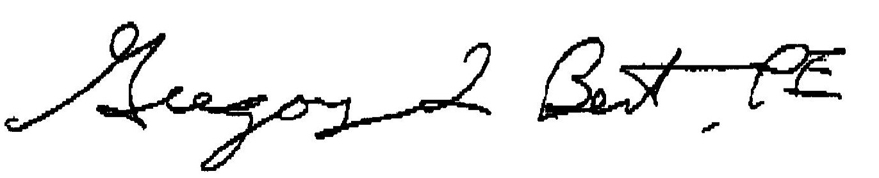
Consulting Engineer

