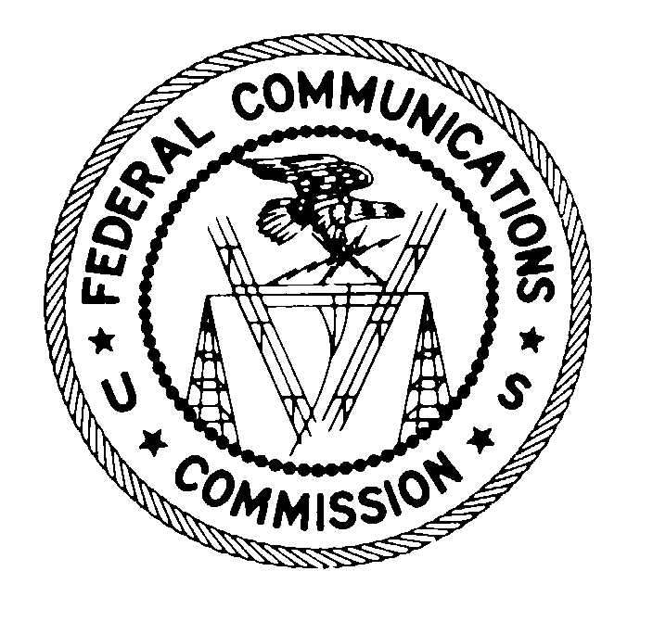
FEDERAL COMMUNICATIONS COMMISSION Washington, D.C. 20554

April 19, 2016

OKLAHOMA BROADCAST ASSOCIATES, LLC
BOX 10094
ENID, OK 73706

In re: LPTV/ TV translator stations: KTEW-LD Fac. ID: 16864

Dear Licensee:
Your license authorization for the above-referenced station is cancelled, therefore you are required to permanently cease operation of the station.
§ 73.3539 (a) of the Commission’s Rules states that:

Unless otherwise directed by the FCC, an application for renewal of license shall be filed not later than the first day of the fourth full calendar month prior to the expiration date of the license sought to be renewed.

Our records indicate that you have not filed the required renewal application within the time period specified by this rule section.

Very truly yours,
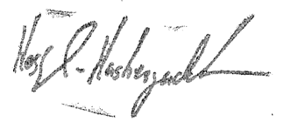

Hossein Hashemzadeh
Deputy Chief, Video Division
Media Bureau

